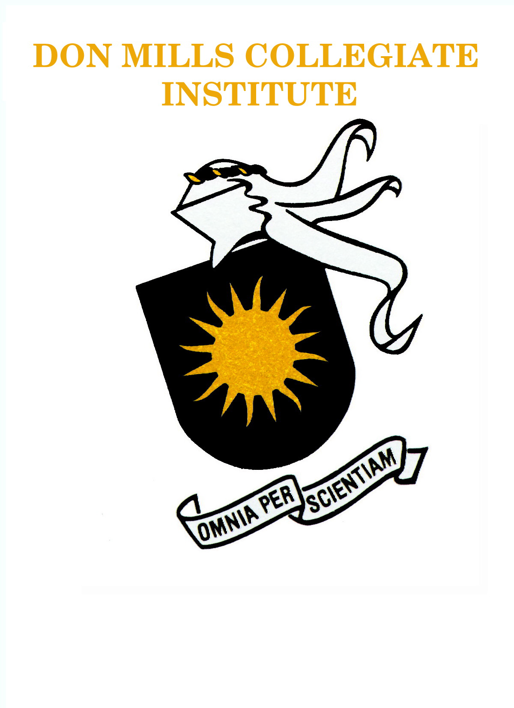
DON MILLS COLLEGIATE INSTITUTE COURSE SYLLABUS

COURSE NAME | Computer Science | GRADE | 10
COURSE CODE | ICS2O | CREDIT VALUE | 1
TEACHER | Mrs. Helen Strelkovska | DEPARTMENT | BCCET
PREREQUISITE | None, TIJ1O1 Recommended

COURSE  DESCRIPTION | This course introduces students to computer science concepts. Students will learn about the stages in software design; the fundamental programming constructs of sequence, selection, and repetition; the functions of internal and external computer components; the relationship among networks, operating systems, and application software and their uses; and how programming languages evolve. Students will also develop an awareness of computer-related careers.

OVERALL  EXPECTATIONS | - describe the functions of different types of hardware components, and assess the hardware needs of users;  - describe the different types of software products, and assess the software needs of users;  - use the basic functions of an operating system correctly;  - demonstrate an understanding of home computer networking concepts;  - explain the importance of software updates and system maintenance to manage the performance and increase the security of a computer.  - describe fundamental programming concepts and constructs;  - plan and write simple programs using fundamental programming concepts;  - apply basic code maintenance techniques when writing programs.  - describe key aspects of the impact of computers and related technologies on society;  - describe computer use policies that promote environmental stewardship and sustainability;  - describe legal and ethical issues related to the use of computing devices;  - describe postsecondary education and career prospects related to computer studies.

TEXTBOOK(S) | REPLACEMENT COST | ADDITIONAL FEES
Online Reading Assignments | N/A

Liability: Students are responsible for broken or lost equipment signed out or damaged in classroom.

COMMUNICATION

Please direct all questions or concerns regarding student progress or program of study to the classroom teacher. The department number is 416-395-3190 ext. 20141. helen.strelkovska@tdsb.on.ca

EVALUATION OF STUDENT ACHIEVEMENT

Evaluation of student achievement is based on the following categories:

Categories | Percentage
- Knowledge | 30
- Thinking | 20
- Communication | 20
- Application | 30

UNITS OF STUDY & EVALUATION TASKS

70% Course Work

UNIT 1 HARDWARE, INTERFACES, BASIC PROGRAMMING CONCEPTS 4 Weeks
EVALUATION TASK | ACHIEVEMENT CHART EVALUATION | WEEK(S)
Programming Exercises (Simple Printing) | K, T | Week 1
Programming Exercises (Input, Calculations, Math Module, Output) | K, T, A | Week 2
Programming Exercises (Conditions, Counters) | K, T, A | Week 3
Test Unit 1 Programming  Test Unit 1 Paper | K, T, C, A | Week 4

UNIT 2 SEQUENCE AND SELECTION ROUTINES 3 Weeks
Programming Exercises (Repetition, Strings) | K, T, C, A | Week 5-6
Test Unit 2 Programming  Test Unit 2 Paper | K, T, C, A | Week 7

UNIT 3 ADVANCED PROGRAMMING CONCEPTS 4 Weeks
Programming Exercises (Repetition, Strings) | K, T, C, A | Week 8-9
String Game Assignment | T, C, A | Week 10
Test Unit 3 Programming  Test Unit 3 Paper | K, T, C, A | Week 11

UNIT 4 PROGRAMMING APPLICATIONS 4 Weeks
Programming Exercises (Lists) | K, C, A | Week 12-13
Programming Exercises (Functions) | T, C, A | Week 14
Test Unit 4 Programming  Test Unit 4 Paper | K, T, C, A | Week 15

FINAL 30 % CULMINATING ACTIVITIES 3 Weeks
Final Assignment (Project Evaluations,  Interview, Presentation) | K, T, C, A | Weeks 16-18
No Exam In Exam Period |  | Exam Period

